Black-Scholes Model Validation
ADVANCED RISK MANAGEMENT, SPRING 2009

Authors:
Nichlas Hawrylyshyn
Viet Hoang
Eduardo Peynetti
Dan Shiber

Contents
1. Executive Summary 3
2. White Paper / Technical Specification 4
3. Testing of Pricing 5
4. Testing of Greeks/Hedge Parameters 9
5. Conditions for use 10
6. Strengths and Weaknesses 11
Appendix 13

1. Executive Summary
In this report we test the Black-Scholes call option pricing formula as implemented in Matlab. This formula is due to an academic paper (Black Scholes and Merton 1973) which develops a mathematical model to price a European call option on an underlying stock. This formula is widely used by practitioners to both price and quote option prices in the market.
This document begins by outlining the technical theory surrounding the Black-Scholes model, as discussed in the 1973 white paper by Merton and Scholes. The authors assume that the underlying stock pays no dividends, that we can borrow and lend at the risk-free rate with no limit. In addition, they assume that that the stock price follows a Geometric Brownian Motion (a technical term describing small price shocks and no big jumps) with constant expected return and volatility.
The actual pricing behind MatLab’s blsprice function will be introduced in section 3 and includes the validation of test data on IBM (a highly liquid equity with liquidly-traded options) with industry approved data from Bloomberg, and subsequent tests when the model’s input parameters are varied to validate against theoretical results.
In addition to the arbitrage-free price of a European call option, the model also provides sensitivity measures (known as Greeks) of the price of the option with respect to changes in current stock price, strike price, stock volatility, interest rate and time. These sensitivities can be used as measures of risk, and thus can also be used for hedging purposes. The testing and pricing portions of this document provide information on the quality of these measures by comparing predicted risk to realized risk.
As a result of several assumptions and theoretical nature of the model, the Black-Scholes call option pricing formula is subject to several strengths and weaknesses. The strengths of the model, as described in the testing section, include speed (due to closed-form formula), popularity (widely used by practitioners), intuitive and easily calibrated to market prices.
On the other hands, the following assumptions are unrealistic and cause some weaknesses in the model: no jumps in stock price, constant known interest rates in the future, no transaction costs, no restrictions on short selling, constant volatility across strikes and maturities and geometric Brownian Motion distribution of stock price. The last assumption infer a log distribution of stock returns, which fail to capture fat tails – a phenomenon that has proved costly for many traders and portfolio managers in the past.
All of the actual code used in this document and testing data, along with end notes are subsequently provided in the Appendix.

2. White Paper / Technical Specification

Fischer Black and Myron Scholes first articulated the Black-Scholes formula in their 1973 paper, "The Pricing of Options and Corporate Liabilities." The foundation for their research relied on work developed by scholars such as Paul Samuelson, Edward Thorp and Bachelier. Later on, Robert Merton expanded the mathematical understanding of the options pricing model. Today, the “Black-Scholes” model is an industry standard for pricing, analyzing and hedging options.

The Black-Scholes model, is a mathematical model of the market for an equity in which the equity's price follows a Geometric Brownian Motion, which means that the model assumes that the logarithmic changes in prices are normally distributed and independent over non-overlapping time periods. The model provides us with a partial differential equation by which we can price any contingent claim on the price of the stock. In particular, it gives us a closed form solution to the price of an European call option on the stock's price.

The Black-Scholes model of the market for an equity option makes the following explicit assumptions:
- It is possible to borrow and lend cash at a known constant risk-free interest rate.
- The price follows a Geometric Brownian motion with constant drift and volatility.
- There are no transaction costs.
- The stock does not pay a dividend.
- All securities are perfectly divisible (i.e. it is possible to buy any fraction of a share).
- There are no restrictions on short selling.

Matlab's implementation of the Black-Scholes model is now introduced. The function blsprice in Matlab computes european call option prices using a Black-Scholes model. The inputs are as follows
Call = blsprice(Price, Strike, Rate, Time, Volatility)
Input Variable | Description
Price | Current price of the underlying asset
Strike | Strike (i.e., exercise) price of the option
Rate | Annualized continuously compounded risk-free rate of return over the life of the option, expressed as a positive decimal number.
Time | Time to expiration of the option, expressed in years.
Volatility | Annualized asset price volatility (i.e., annualized standard deviation of the continuously compounded asset return), expressed as a positive decimal number.

Output Variable | Description
Call Price | Price (i.e., value) of a European call option.

As an example to help illustrate the nature of the function blsprice:
Consider European stock options with an exercise price of $95 that expire in 3 months. Assume the underlying stock pays no dividends, is trading at $100, and has a volatility of 50% per annum, and that the risk-free rate is 10% per annum. Using this data,
Call = blsprice(100, 95, 0.1, 0.25, 0.5)
Call = 13.6953 % or $13.70
As general note to those familiar with Matlab syntax: Any input argument may be a scalar, vector, or matrix. If a scalar, then that value is used to price all options. If more than one input is a vector or matrix, then the dimensions of those non-scalar inputs must be the same.

3. Testing of Pricing

In this section of the document we outline our testing of the functionality of Matlab's call pricing function (blsprice) and compare its results to market prices quoted in Bloomberg.
Test Scenario #1: We collected call option prices on IBM (a highly liquid equity with liquidly-traded options) and implied volatilities from Bloomberg, a standard source of financial information. Then we tested the quoted prices vs. the prices we get from Matlab using the function blsprice(S,K,r,T,sigma) where S is the stock price, K is the call strike, r is the risk-free rate, T is the time to expiration in years, and sigma is the volatility of the stock.
Result: The prices matched exactly, providing 3rd party model validation to the Matlab call pricing routine.
Test Scenario #2: We tested the behavior of the model when input with negative volatility, zero volatility, negative rates, zero rates, negative equity price, zero equity price, and negative time to expiration.
Result: The blsprice function correctly detects an error in the cases negative volatility, negative rates, negative equity price, and negative time to expiration. Zero volatility does not result in an error; this is consistent with Black-Scholes pricing.
Test Scenario #3: We plotted the price as a function of strike.
Result: As seen in the figure below, we verified a convex relationship as expected from the Black-Scholes paper and from practitioner use.

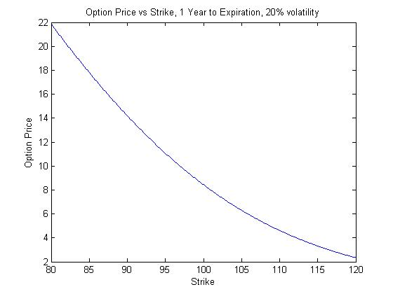
Figure 1
Test Scenario #4: We plotted the price as a function of volatility.
Result: As seen in the figure below, we verified a convex relationship as expected from the Black-Scholes paper and from practitioner use.
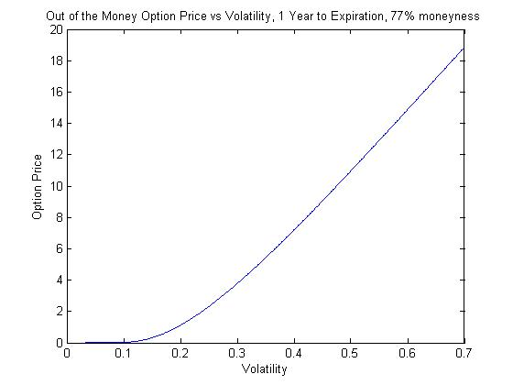
Figure 2

Test Scenario #5: We plotted the price as a function of time-to-expiration.
Result: As seen in the figure below, we verified a convex relationship as expected from the Black-Scholes paper and from practitioner use. We also verified that the price grows larger as time to expiration gets shorter and all other parameters are held constant as expected from the Black-Scholes paper and from practitioner use.
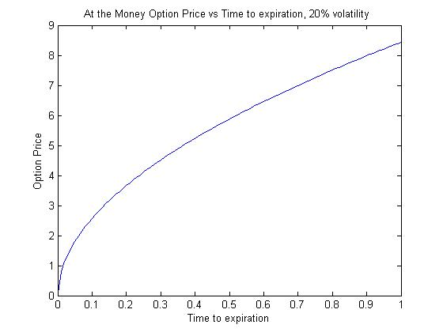
Figure 3
Test Scenario #6: We plotted the price as a function of stock price, with zero time-to-expiration.
Result: As we see in the figure below, we reproduced the expected hockey stick shape.
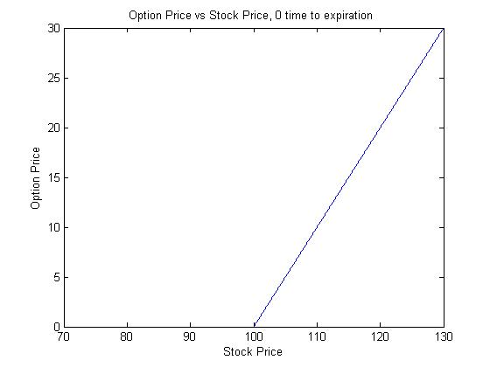
Figure 4
Test Scenario #7: For each strike, we used the implied volatility obtained from that strike in order to produce prices for all strikes. Then we computed the root mean-squared error (RMS) compared to market prices. This gives an RMS for each implied vol.
Result: Using a single volatility produces incorrect prices when compared to market prices. As seen in the at-the-money volatility produces the smallest RMS.
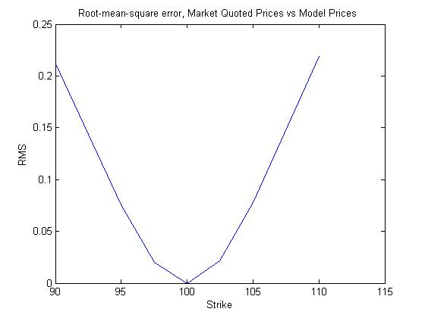
Figure 5

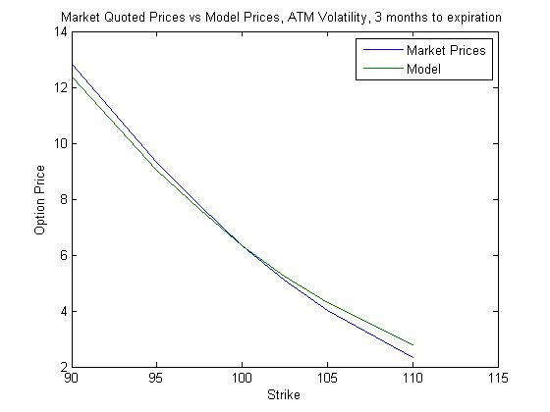
Figure 6

4. Testing of Greeks/Hedge Parameters

In this section we test the Greeks produced using Matlab's call pricing function (blsprice) and compare its results to Greeks quoted in Bloomberg.

Test Scenario #1: We test the value of Delta computed as:
[blsprice(S+h,K,r,T,sigma)-blsprice(S,K,r,T,sigma)]/h
with h chosen bigger than zero and small compared to S. The theoretical value is computed as Delta=N(d1) with N the cumulative normal distribution and 1=[ln(S/K)+(r+sigma^2/2)T]/[sigma*sqrt(T)].
Result: The absolute error is 10^-7 and the relative error (compared to S) is 10^-6.

Test Scenario #2: We test the value of Gamma computed as
[blsprice(S+h,K,r,T,sigma)-2*blsprice(S,K,r,T,sigma)+blsprice(S-h,K,r,T,sigma)]/(h^2)
with h chosen bigger than zero and small compared to S. The theoretical value is computed as Gamma=N'(d1)/[S*sigma*sqrt(T)].
Result: The absolute error is 10^-8 and the relative error (compared to S) is 10^-7.

Test Scenario #3: We test the value of Vega computed as
[blsprice(S,K,r,T,sigma+h)-blsprice(S,K,r,T,sigma)]/h
with h chosen bigger than zero and small compared to sigma. The theoretical value is computed as Vega=SN'(d1)sqrt(T),
Result: The absolute error to theoretical value is 10^-6 and the relative error (compared to sigma) is 10^-4.

Test Scenario #4: We test the value of Theta computed as
-[blsprice(S,K,r,T+h,sigma)-blsprice(S,K,r,T,sigma)]/h
with h chosen bigger than zero and small compared to T. The theoretical value is computed as -SN'(d1)sigma/[2sqrt(T)]-rKexp(-rT)N(d2) with d2=d1-sigma*sqrt(T).
Result: The absolute error is 10^-4 and the relative error (compared to T) is 10^-5

Test Scenario #5: We test the value of rho computed as
[blsprice(S,K,r+h,T,sigma)-blsprice(S,K,r,T,sigma)]/h
with h chosen bigger than zero and small compared to r. The theoretical value is computed as Ktexp(-rT)N(d2).
Result: The absolute error is 10^-7 and the relative error (compared to r) is 10^-6

5. Conditions for use

Options are extremely risky instruments which magnify risks and losses due to their convex dependence on the underlying equity price. They can also be used to increase leverage significantly. For these reasons, care must be taken when trading with options, and the trader must be familiar with the downsides, the possibility for quick price changes, the hedging argument which provides the rationale behind the Black-Scholes call pricing formula, and the meaning of the various greeks used to manage the risk. There can also be significant differences between the model price and real market prices due to a variety of scenarios, e.g. event risk which may case jumps (violating an assumption described below), demand for options to provide additional leverage to a trader capitalizing on information about an equity, etc.
The blsprice function described throughout this document relies on the Black-Scholes call pricing formula, which in turn relies on the following assumptions:
- The underlying is an equity.
- The equity price does not experience jumps.
- The log-returns of the equity are normally distributed, independent across non-overlapping periods.
- The equity pays no dividends.
- The user of the formula can borrow and lend at the risk-free rate (which may differ from user to user based on the user's credit situation and access to central bank capital).
- The risk-free rate is constant during the life of the option.
- The user of the formula experiences no transaction costs for buying and selling the underlying equity.
- The equity is infinitely divisible.
- The user of the formula experiences no restrictions on short-selling.
- Only one call is priced at a time. Otherwise, to match market prices we need to use several volatilities – one for each strike and maturity.

Any user of this functionality must be aware of the effects that these assumptions have on the model and how they cause the model to behave differently than option prices in real life.

6. Strengths and Weaknesses

The blsprice has the following strengths
- Extremely fast pricing formula (closed-form, requires no simulation)
- Widely used by practitioners -- in fact call prices are quotes through a measure called implied volatility which is calculated using this model
- Provides accurate risk measures of the call price (closed-form, requires no simulation)
- Intuitively understandable by practitioners, while capturing the inherent convexity in the option
- Easily calibrated to market prices.

The blsprice has the following weaknesses
- Assumes no jumps in the equity price, which may occur due to news or large market orders.
- Assumes constant known interest rate in the future, though interest rates are not constant and can at best be expected (not known).
- Assumes no dividends, which is not the case for many equities.
- Assumes no transaction costs, which depending on the size and exposure of the desk may not be true.
- Perfectly divisible securities.
- No restrictions on short selling, which is not true due to limits imposed by risk management.
- Constant volatility across strikes and maturities, which is not true as discussed in the Testing of Prices document.
- Assumes equity prices follows geometric Brownian Motion and as a result that log returns do not have fat tails – though fat tails have been observed in the market.

Appendix

Attached is the source code for testing our results:

MATLAB File Description | Reference to actual File
testData.mat : data file containing our test data | 
createData.m: Used to load testData.mat into MATLAB environment | 
test.m: Test Script which uses createData to load file and does tests as described in sections 3,4 of this document. | 

http://efinance.org.cn/cn/FEshuo/The%20Pricing%20of%20Options%20and%20Corporate%20Liabilities.pdf

